**Assignment Lab1: Create VLAN for the following scenario**

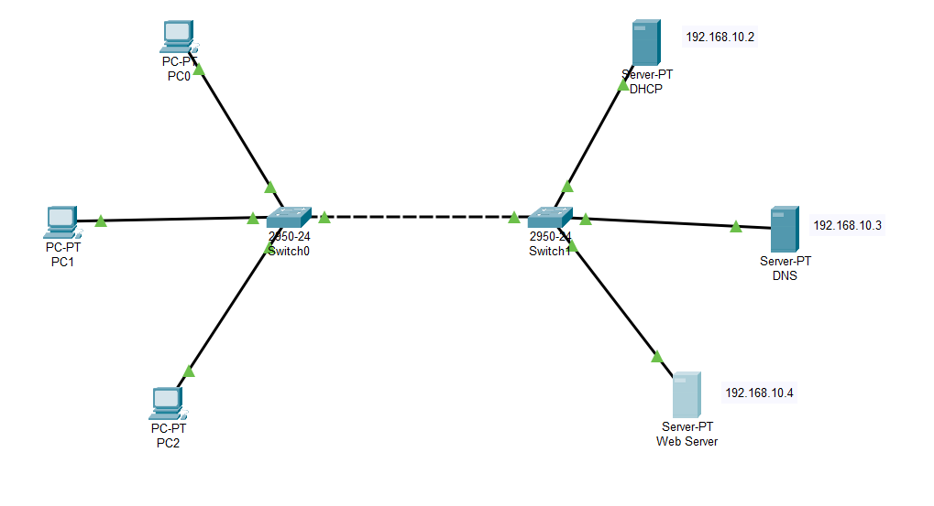

**Notice some points:**

* + First we have to connect all hardwares properly.
  + Now we need IP configuration and do the Services part of **DHCP,DNS,Web Server**.
  + Then we go to **pc(pc0,pc1,pc2)** IP Configuration.
    - * Here we on **DHCP button**(not static).we will find that the IP Configuration of all PCs generate automatically on the basis of DHCP start IP address .

**All the steps are shown blew:**

**1.DHCP:**

IP Configuration:

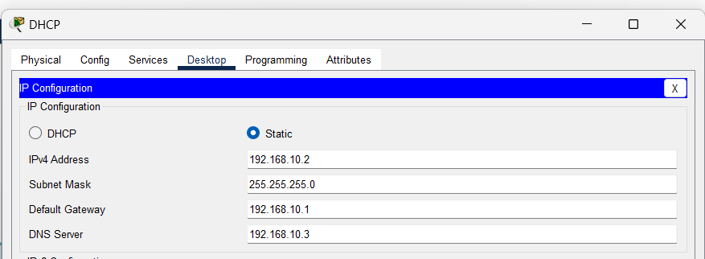

Services:

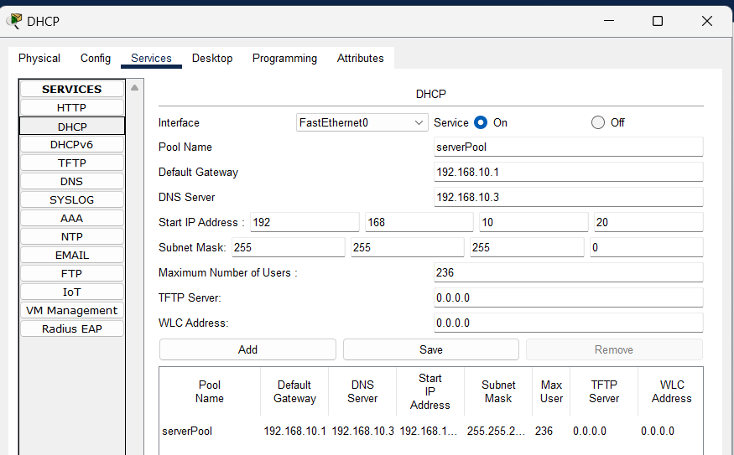

Arbitrary

**2.DNS:**

IP Configuration:

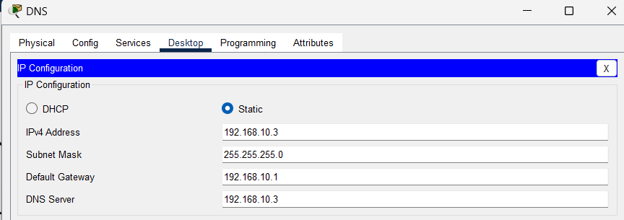

Services:

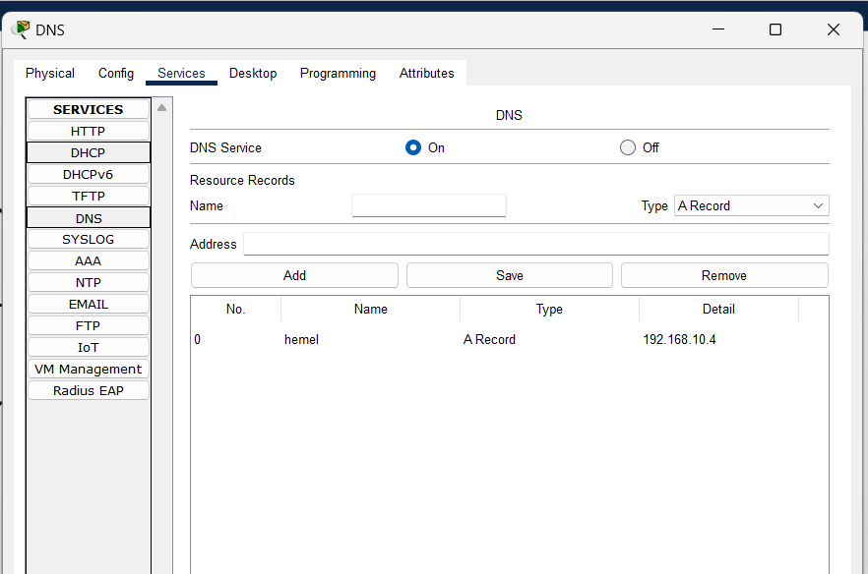

**3.Web Server:**

IP Configuration:

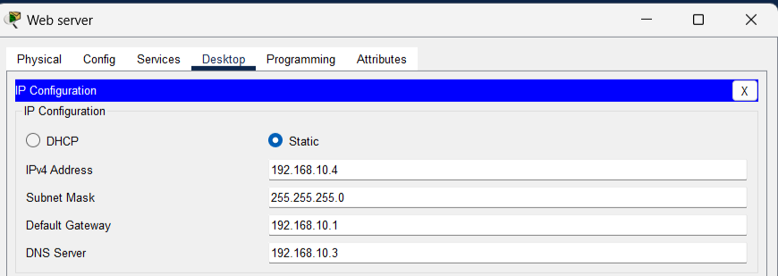

Services: HTTP button must be on

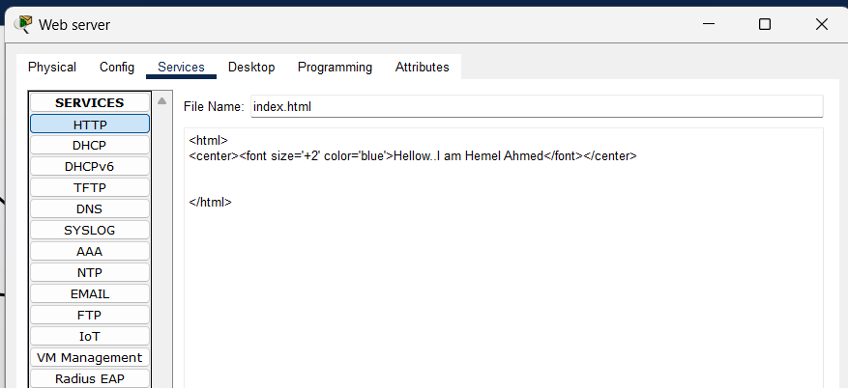

**4. IP Configuration of all pc:** we have to on DHCP button and configuration become automatically.

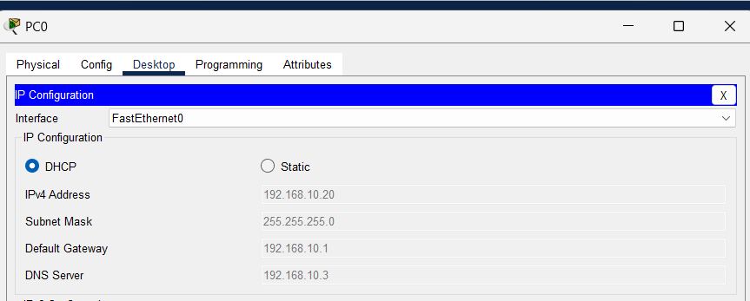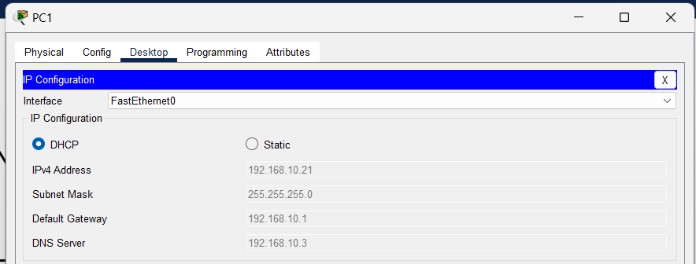

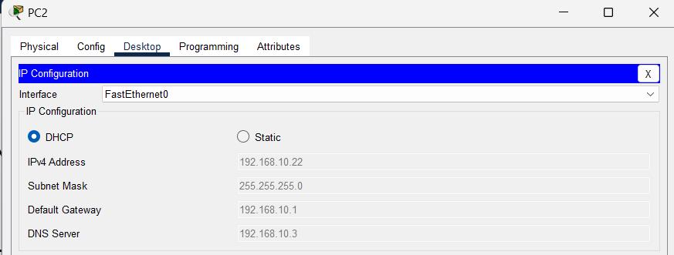

In DHCP server we start ip address at 192.168.10.20.So PCs are contain (20,21,22)

**Now we pass the packets and web browsing..**

